AddCoins Mastery Assignment
Reflection Log
Stefan S
CSE 2110 Procedural Programming 1
(AddCoins.java)
How has your program changed from planning to coding to now? Explain.
This was the first working version of the program:
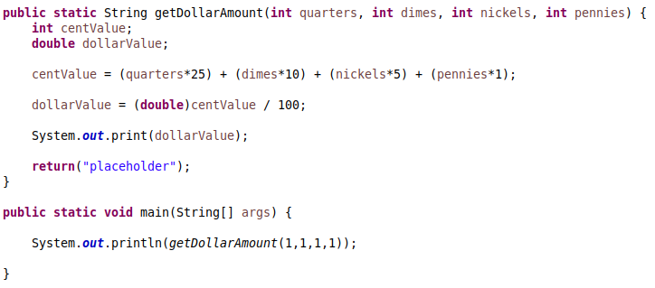
From here I still have to add number formatting and the user’s input

From this point, the main portion of the program was not hard to write. The part that was exceedingly difficult, and that took the most of my time, was the input handling method.
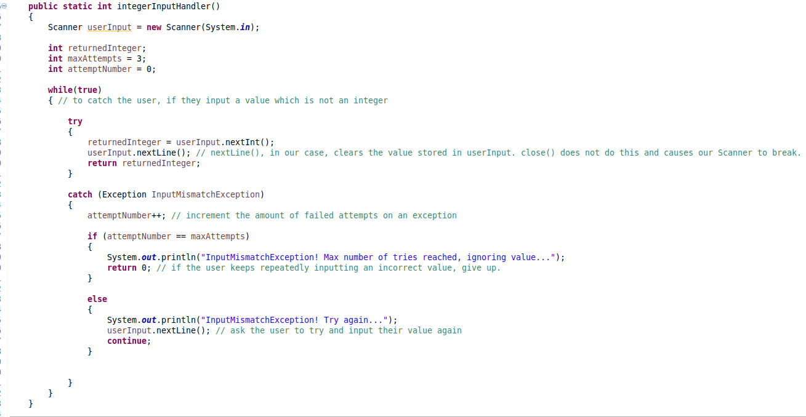
You can bet 100% that I will be using this method in my future programs. It will probably save me a ton of time when it comes to handling inputs.
In theory I could just import this class into my future projects and re-use the same method, but in all likelyhood I will be copy/pasting the method into the program directly for convenience sake. It would only make sense to import the class if it was part of a larger program.
The other parts of the program look as follows:
